**M.Organ Documentation!**

**1) Excel file correct form:**

i)To see your Expenses in M.Organ web app you must have an excel file like the form below.

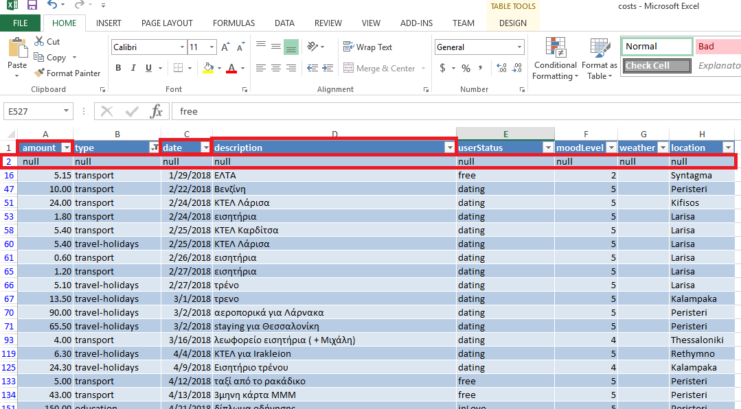

Amount the first column have to be called “amount”, and must add at least 2 extra columns, “date” and “description”.

ii) It has to be the first row with “null”.

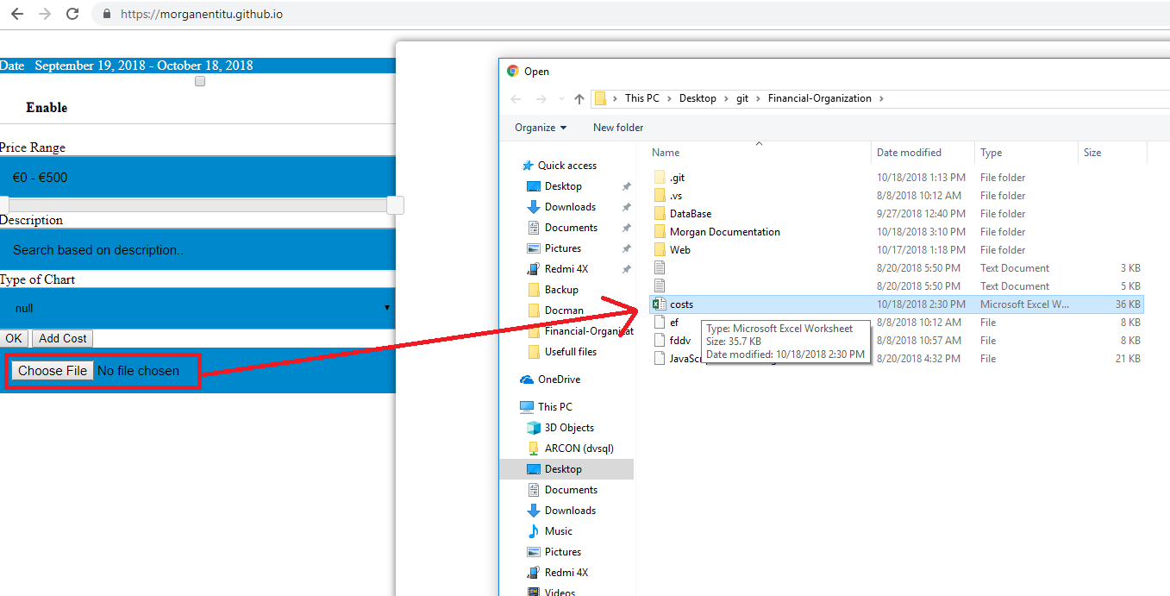 **2) Import your excel file into M.Organ site:**

To auto generate html filters for your expenses, like the image below!

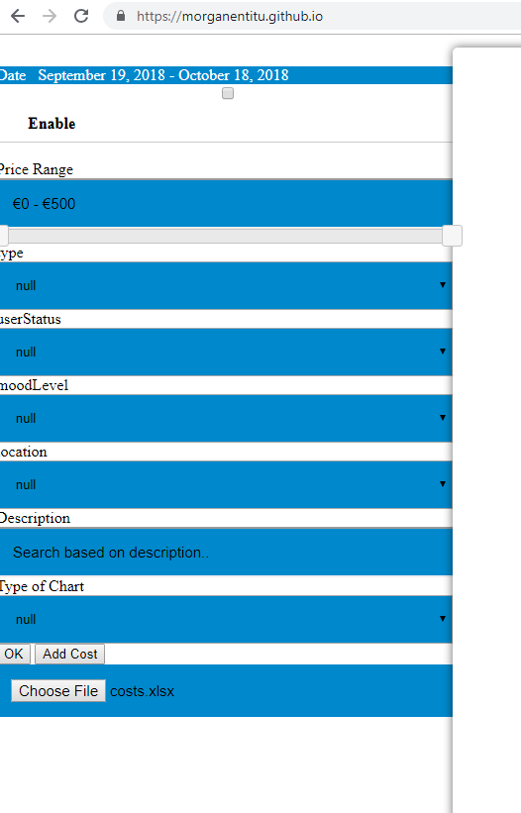

**Date**

**Amount**

**Type**

**User status**

**Mood level**

**Location**

**Description**

**(with green are the predatory)**